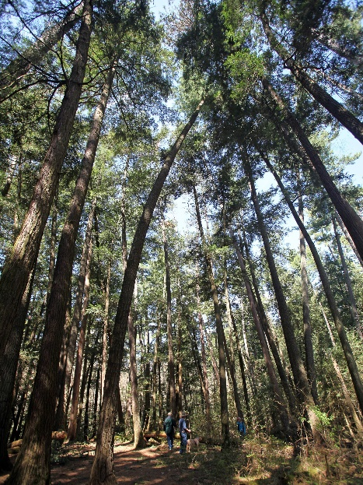

FINAL REPORT:

Reused Wood

Team 8
Mikenzie Crowther, Trevor Gustavson, & Stephanie Mahar
Project Management MAN 370, Professor Gerard

Table of Contents
1 Project Initiation 3
1.1 Project Selection 3
1.2 Benefits 3
1.3 Preparation of the documents to sanction the project 4
1.4 Assigning of the project manager 4
2 Project Planning 5
2.1 Definition of the work requirements 5
2.2 Definition of the quality and quantity of work 7
2.3 Definition of the resources needed 9
2.4 Scheduling the Activities 10
2.5 Evaluation of the various risks 14
3 Project Execution 14
3.1 Negotiating for the project team members 14
3.2 Directing and managing the work 14
3.3 Working with the team members to help them improve 15
4 Project monitoring and control 15
4.1 Tracking Progress 15
4.2 Comparing actual outcome to predicted outcome 16
4.3 Analyzing variances and impacts 16
4.4 Making adjustments 17
5 Project Closure 17
5.1 Verifying that all of the work has been accomplished 17
5.2 Contractual closure of the contract 17
5.3 Financial closure of the charge numbers or members 18
5.4 Administrative closure of the paperwork 18
6 Appendix 18
Appendix A 18

Project Initiation

Project Selection
This project is to remove wood to be reused rather than sending it to landfills or burning it. The goal of this project is to maintain the historical and aesthetic value of old wood and the mission is to provide a greener option when it comes to taking down old buildings. It is important to understand the difference between demolition and deconstruction. The cost of demolition can be upwards of $50,000 and sends all or almost all of the waste to landfills. Most often, the materials being sent to landfills can instead be removed safely and be reused. With deconstruction, the majority of the materials are sent to be refurbished and reused. This project focuses specifically on wood from old buildings. This can be found as floorboards, support beams, and inside of the walls as the main interior structure of the entire house.
The choice to take on this project was easy. There are a lot of potential benefits which is the main reason each of us selected this project. There is much potential for positive outcomes if this project is successful. At the start of this project, we were the recycled wood group, but er quickly learned that we do not want to recycle, so much as reuse the wood. By taking this approach, we are changing the way the project is to be executed because we will not be reprocessing the wood, but will be maintaining the natural qualities of the wood.

Benefits
The benefits of this project are vast. One beneficiary is the environment. This project will greatly benefit the environment in a variety of ways. By reusing old wood rather than burning it or leaving it to decay naturally in our landfills, we are able to reduce green house gasses. Anytime something is burned, green house gasses are released into the atmosphere which is worsening the effects of global warming. Likewise, as materials decay, they release hazardous gasses. This idea of reusing wood also keeps us from needing new wood as often, meaning less deforestation and more trees to convert carbon dioxide into healthy, breathable oxygen. Another beneficiary of this project is the local community of and around the Springfield area. Our main stakeholder is Pam. She is the one making decisions about this project. She has repeatedly stated how she intends to source resources from the Springfield area. Springfield is traditionally a more impoverished city than the locations surrounding it. This project means bringing job opportunities to Springfield.
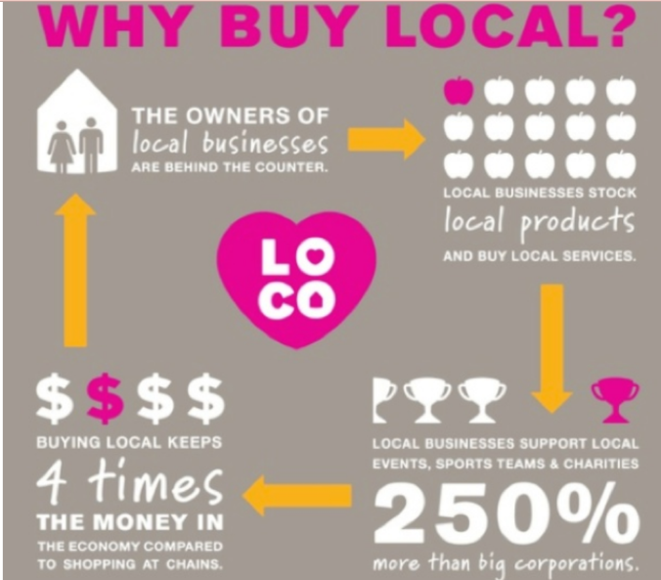
This project could help to uplift the Springfield community. Pam’s intention to support this project with purely resources sourced from the Springfield area will also aid in keeping money in Springfield and bringing new money into Springfield. As we purchase old wood from sites in Springfield and sell our finished product to companies located within the Springfield area or from outside the Springfield area, we will be investing that money back into Springfield by buying local products.
There are however challenges that need to be considered as well. One potential challenge is that there will not be enough wood for us to use in the area we are looking to purchase within. Because of our narrow view on the aesthetic quality of old wood we are looking to rescue from deconstruction sites, it is possible that we will not have the means to acquire enough to turn a profit and recover start-up expenses. We will also be losing up to 40% of our wood in the process of refurbishing it. Any pieces of metal or other materials that are stuck to the wood will need to be removed, a process which can mean losing some parts of the wood. Then the wood will have to be put through the joiner and plainer to remove splinters and minimize the effects of warping that has effected the wood over time. This takes off a good portion of the wood, but efforts can be made to minimize our waste. One potential way to combat this loss of wood is using our wood scraps to make particleboard and MDF wooden boards. There are also various uses for sawdust meaning that we may be able to harvest the sawdust created throughout the process and resell it to those who can put it to better use.

Preparation of the documents to sanction the project
To open a business in the city of Springfield, we must first meet with a representative of the city of Springfield to obtain a business license. We do this by taking the following steps:
- Requesting to meet a representative through the city hall. The application form to apply for a business license should be printed off of the city of Springfield website and then hand delivered to the City hall. The License Commission will then meet and decide if we are to be granted the business license.
- We will also need to submit a Certificate of Occupancy application which can be printed out online. There may be other forms necessary before we are able to operate a business in the city of Springfield.
- To discover if there are any other forms we will need to submit for our specific project, the City of Springfield Department of Code Enforcement will need to be contacted by phone at 413-787-6031.
- Our business license application will need to include our business name, the physical address of our business, our business mailing address, ownership information (sole proprietorship, and LLC, or part of a larger corporation), current contact information for all owners, our federal tax ID number, state seller’s permit, state tax number, contractors license number, signature and date.
- This means we will also need to acquire a federal tax ID for the business. This can be done through the IRS website. Once the validation is complete, an EIN will be immediately granted and the confirmation notice can be downloaded and saved.
- We will also need a Sales Tax Permit from the Massachusetts Department of Revenue (also known as a seller’s permit, sales tax number, or sales tax license) and then a Resale Certificate (ST-4) from the Massachusetts Department of Revenue in order to conduct sales where we charge our customers sales tax rather than paying sales tax for the acquisition of our wood.
- This also requires a Massachusetts Vendor registration which we can register for on mass.gov.
- We will need to register for a State Tax ID which we do by navigating to the secretary of state’s website and locating our business division. We then download the form for a state tax ID, complete it, and return it to the secretary of state by following the directions on the form. The state will notify us when our ID has been issued.
- We may or may not also need to acquire a contractors license which we can get through mass.gov.

Assigning of the project manager
Our project manager is Pam. She has been taking control of the project and will continue to do so as the project progresses. As we gain project office personnel, they will be reporting directly to Pam. Pam is currently the project manager of Windows Workshop and she has the needed experience to make this project successful. Pam is also very knowledgeable about the process of reusing wood and the necessary equipment and resources to executing the project well. Pam already has a high position of responsibility in the project by stepping up as the individual attempting to see the project through. She has also proven through the success of her Windows Workshop that she can handle this responsibility. Pam’s specialized knowledge about working with wood, managing employees, project planning, scheduling, and control is what makes Pam the right fit to be the lead project manager.
Other options were considered, but ultimately turned down. One option was the students taking on the project each semester, but because this group changes so often and there is a time between semesters where students are not available, this idea is not feasible. Another option was Fred Rose whose work with Wellspring Cooperative would give him useful resources to apply to this project and experience as a project leader, but he is too busy with his other work to bring the much needed attention to this project and the project would most likely not reach fruition.
At some future point, Pam may assign another individual as the project manager and step down from the position. This individual will most likely be someone who begins as a trainee at the training center and sees the project as it grows and develops. Pam has expressed interest in helping the project as it is starting out and eventually retiring and leaving the project and business in the capable hands of someone else whom she has yet to meet.

Project Planning

Definition of the work requirements

Scope of Work:
The creation of a business model for the acquisition of old salvaged wood, processing, and selling of reused wood. Part of the business model includes the creation of a local wood training program. The business type is a worker cooperative business.

Project Description:
The far-reaching goal of the project is to provide quality jobs for the surrounding community and greater Springfield area of Massachusetts, employ sustainable business practices, reduce waste, benefit the community, and additional sustainable environment advantages.
The process of reusing wood is to salvage old growth wood, transform the wood into a new desired and deliverable product (ie. floorboards), meanwhile focusing on sustainability and supporting the local community. Large pieces of old growth wood (ie rafters or joints) would be derived from the local area, transformed using various equipment into the end desired product, customized to each end customer. The domain is business to business.

Training Program Description:
The goal of the local training program is providing a safe environment for local youth to learn valuable advanced technical skills at no cost. The RW project will require employees with advanced technical skills and experience with wood and various machinery, the graduates of the training program will become employees of RW. The training program is a hands-on environment that would teach students how to process an input (old salvaged wood) into the output (floorboards). The students would receive education on techniques and skills related to the processing of the wood, equipment experience, and safety training. The trainees would be working towards completion of the program and learning the necessary technical workshop skills, meanwhile provided the opportunity to obtain advanced training and certifications. In addition, upon satisfactory course completion students would receive various certifications related to safety as well in accordance with OSHA regulations.
*Please see Appendix A for further details about Training Program

OBJECTIVES:
A successful project has the following basic objectives: “within time, within cost, at the desired performance/technology level, while utilizing the assigned resources effectively and efficiently, [and] accepted by the customer” (Kerzner 3). An estimated timeline of the project is three years. The precise budget of the project needs additional planning to be fully determined and was unable to be estimated at this time. The performance levels will be determined with help of the Project Manager and Sponsor.
The Reused Wood project strives to meet the standard project objectives and meet ones unique to the project. At this point, it is recommended that the project team will identify specific metrics related to the general objectives listed below.

- Training Program
  - Provide local employment: 1 full time job (Lead Trainer)
  - At end of first year operation, fully train minimum of 2 students
- Benefit the Community
  - Reduce waste in local community
  - Sell and Buy Locally
- Waste Reduction
  - Preliminary Goal of 70% Waste Reduction within Wood Processing
    - Goal is to increase waste reduction over time
    - Implement organizational policies (ex. Sawdust will be captured and recycled, not disposed of)
- Provide local jobs

The objective of providing benefit to the community aligns with the objectives of the Massachusetts Department of Environment Protection. The MassDEP has implement significant waste disposal bans which incentivize and support the recycling and reuse industry. The project strives to align with the goals of minimal waste in all processes.

Note: Due to time constraints, unable to complete a comprehensive risk assessment and forecasting. This should be completed at a later point which would assist in creating more specific project objectives (Kerzner 67).

Project Location:
There project consists of several locations. main locations include the training program space (GNLC) and a facility that houses the central operations of the co-operative. The location of the training facility is known and the other facility location is undetermined.
A requirement of the project is a building or warehouse that would house the central operations of the project. This building is not a requirement until the Project Execution stage. The ideal location of the central building or facility is in the city of Springfield, preferably near the highway. A possible building in the area is of interest is the Needle Exchange Building in downtown Springfield. Further investigation needs to be conducted regarding feasibility. The building does contain desirable attributes related to location and large property size.
The headquarters of the training facility and training space will reside in Indian Orchard, the exact address is listed in the next subsection. The lead shop instructor and trainees will work at this site. It is still to be determined the full list of other locations in which the project team will work from. An option of location is remote work. The team can work remotely and frequent virtual meetings. The option of remote working is favorable whenever possible to adhere to current necessary COVID-19 precautions.

Training Program Location: The program would utilize available space at Greater New Life Christian Center (GNLC), located in the city of Indian Orchard, Massachusetts.

1323 Worcester Street, Indian Orchard, MA 01151-1621
Note: It is assumed the space at GNLC will still be available after securing monetary start up.

Project Requirements:
The requirements of the project include creation of a Training Program and the additional requirements associated with the program. Other requirements are acquiring funding for the central operations building and various costs associated with it including labor, equipment, insurance, rent/mortgage, ect.
Training Program Requirements:
The table below describes the costs required for the Training Program for the first 4 months. The cost breakdown was provided in documentation received by group (see Appendix A). The Insurance Cost was modified to show the total cost for 4 months, original documentation only showed cost for 4 weeks. The total cost for 4 months of the start up of the Training Program is $20,900.
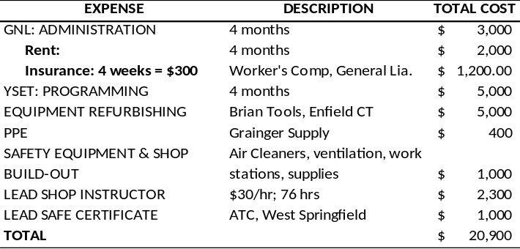

Stakeholders
The main stakeholders of the project are identified below. The list was created with the available knowledge and information generated over the course of the semester.
- Pam Howland
- Wellspring Cooperative
- Fred Rose (co-director, co-founder of Wellspring)
- Salvage Wood Suppliers:
- Contractors
- Tree removal companies
- House flippers
- Local Waste Disposal sites
- Construction Companies
- Construction Sites
- Individual Suppliers
- Buyers of Salvaged Wood:
- EcoBuilding Bargains
- Contractors
- House Flippers
- Other Buyers (Local Small Businesses)
- End Users of Wood
- Community: city of Springfield, surrounding region, and state of Massachusetts
- Competitors: some small competitors in local area that also sell reused wood in various forms

Definition of the quality and quantity of work
The quality and quantity of work cannot be precisely estimated at this time. Future recommendations are for a full breakdown of quantity and quality of work, which is required to create a budget that is based upon performance results standards (Kerzner 567). The product cost needs to be determined for a specific amount of floorboards. The cost of quality and quantity of work can broken down into four categories of cost data or product cost data:
Direct Materials (DM): cost of input (wood) and any additional materials (ex. product used to treat wood)
Direct Labor (DL): # of labor hours needed to complete “x” amount of floorboards
Manufacturing Overhead (MOH)
Other direct charges
During the execution phase, the project team is estimated to consist of less than 5 individuals. The quantity of wood processed will be proportional to the number of employees, machinery, and raw materials. For example, when just starting out the model includes the bare minimum requirements of equipment and machinery. As the business expands and acquires more resources, additional equipment can be purchased that will result in a quicker and faster process. The direction of change desired is better quality, and as the project acquires more resources work will become more efficient by being able to accomplish a greater quantity of tasks. In addition, if any trainees began to work on the product while supervised, it will require a greater quantity of work because the trainee is developing their skill set. The more experience the trainees receive on handling the wood and the equipment processes especially safety, the end result will be of higher quality and finished in less time.
It is important to note relating back to the objective of the business is job creation. As the business grows larger, the goal is to continue providing jobs and hands-on with the wood. It is estimated there will be minimal to zero automation as automation would conflict with the project’s main objectives.
Quality: There are six quality management concepts: Quality policy, Quality objectives, Quality assurance, Quality control, Quality audit, and Quality program plan (Kerzner 771). Special attention to each of these six quality management concepts will be undertaken. The quality management concepts will be implemented during the project planning stage for the project and will also be implemented during other stages including the execution stage. The culture of the organization will always emphasize quality and embed it in all actions. The business structure will also reward employees to put quality work into the product as they will also receive the reward.
Quality of Inputs: The input into our process, salvaged wood, has many desirable quality characteristics. The choice of solely using this wood speaks to the adherence to quality the project strives for. Other competitors online may use fillers in their wood or misrepresent the age and condition of the wood. The wood used will be 100% reused old, salvaged wood. New growth wood will never be used. In addition, many quality control measures will be used. Foreign material such as nails and metals will be removed, as well as the wood will receive the appropriate treatments to remain in good quality for years to come. The wood type of old salvaged wood is of high quality, it is known for its durability and remarkable beauty.
Overall Quality: At this early point, the specific quality concepts cannot be fully described in enough detail with the information available. Guidance will be offered for recommendations on putting these concepts into action. The quality objectives need to be obtainable, define specific goals, be understandable, and state specific deadlines (Kerzner 772).
Project Budget: The project budget is suggested to be created from a mix of “historical cost[s]” and “best estimates” (Kerzner 580). This process will include: “identify planned manpower requirements, contract allocated funds, and management reserve” (Kerzner 580). The specific manpower requirements and other product costs will be determined through the Quality and Quantity of work.

Definition of the resources needed
This project will require a lot of resources to be completed. There are many different machines and equipment that will be necessary to make a project like this a reality. We will need resources such as sanders, saws, dumpsters, trailers, trucks, etc.
Our project manager, Pam, already works in a local shop that makes windowpanes. This workshop has a lot of machinery in it already. The machinery Pam already has included things such as sanders, saws, drills, and much more. However, we will need to purchase additional machines that are designed to make floorboards or other aesthetic wood products.
To make any money in the reused wood industry, a company must gather mass quantities of wood. We will need resources that gather these massive quantities of wood from local sites. This means resources such as trailers, trucks, and dumpsters will be needed. Pam wants to get a list of local demolition permits issued by surrounding towns. She would then like to contact the project manager from these sites to salvage the wood. These will require large trailers to haul the wood back to the workshop. In addition, we believe it could be a clever idea to have a dumpster so these people can sort out wood during demolition. These dumpsters would either be rented to purchased. However, the dumpster needed to be hauled out by a special truck. It is more likely we will rent these dumpsters when they are needed. Trucks will be needed to row trailers. In addition, it is possible that for smaller pickups we could use the bed of a pickup truck to haul wood back to the workshop. It is important to have these resources because, like mentioned before, we will need massive quantities of wood to make any money in this market. Our group discovered in our research that about 40% of a piece of wood goes to waste while attempting to reuse it. We must have these resources to make sure we don’t miss any opportunities to gather potential reusable wood.
Another valuable resource is human resources. We can make all the trucks and machines needed to be successful, but if we don’t have the people it will all fall apart. Our team will need to locate several employees to begin the project. These people will drive the trucks and load trailers in the process of acquiring wood.

Scheduling the Activities
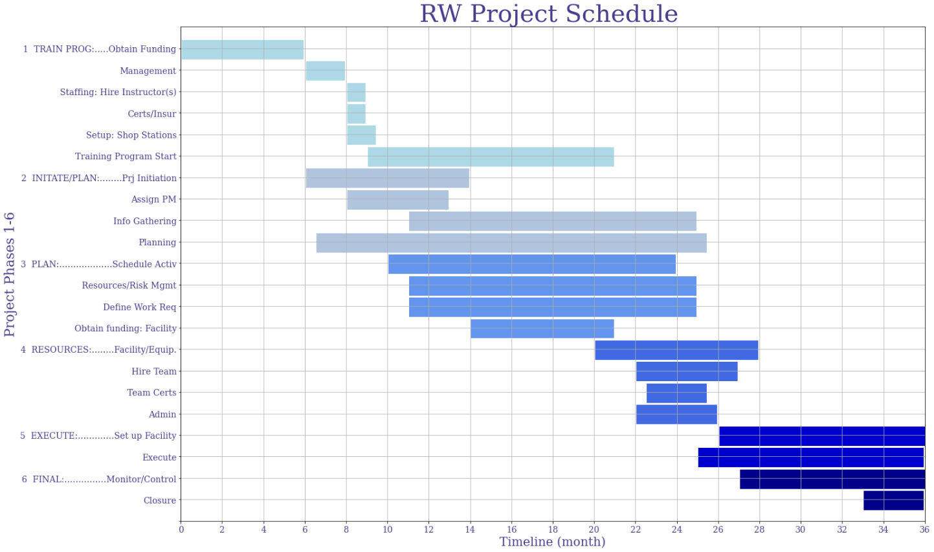
Project Schedule
The Reused Wood Project Schedule breaks down required activities of the project into six different phases. Each phase is sequentially ordered related to time. Also, the chart spans 36 months. This is an estimation of the time the project will require until completion. As further work is completed on the project this timeframe will be adjusted accordingly, the timeframe is heavily dependent on acquiring start-up funding.
Project Process
Phase breakdown:
Phase [1]: Training Program Phase [4]: Resources
Phase [2]: Project Initiation / Planning Phase [5]: Execution of Project
Phase [3]: Planning Phase [6]: Final: Monitor/Control & Closure

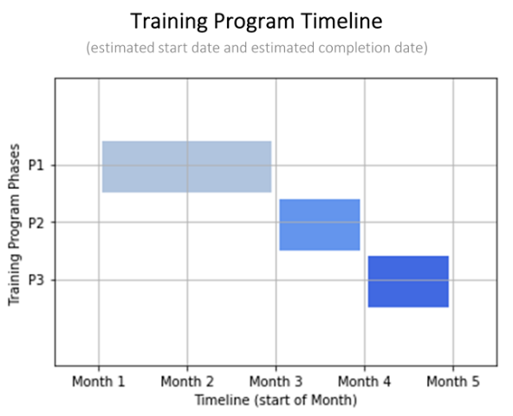
Phase [1] - Training Program:
The first process of the project is creation of the training program and the subsequent execution. The first requirement is acquiring funding for the Training Program to begin further project steps. The main Project Phase [1] can be divided into three sections. The Training Program (assuming funding is acquired) requires an estimated minimum of three months of planning before execution. The activities below are specific tasks required to complete for the training program. The diagram to the right breaks down the timeframe for the Training Program.
- Phase 1.1 Management
- Phase 1.1 Staffing: Hire Instructor(s)
- Phase 1.2 Certification / Insurance
- Phase 1.2 Setup: Shop Stations
- Phase 1.3 Training Program Start (Kick Off Event)
Note: The RW Project Schedule lists “Training Program Start” as lasting 12-months. For scheduling purposes pertaining to the entire project duration, the 12-month timeframe allows a sufficient timeframe for trainees to complete full training.

Phase [2]: Project Initiation / Some Planning:
The second phase of the project is primarily focused on activities in the Project Initiation stage. All Project Initiation stage activities will be completed during this stage. In addition, some general planning activities will begin.
- Project Initiation
- Hire/Assign Project Manager
- Information Gathering
- Planning

Phase [3]: Planning:
During the third phase, critical deliverables centered on Project Planning will be created. The third phase is where many deliverables of the Project Planning stage will be started and finished. This stage is labor intensive in the creation of this documents and further narrowing down scope of the project while also connecting with outside resources. A milestone of this stage is acquiring funding for the Reused Wood facility.
- Schedule Activities
- Resources
- Risk Management
- Define Work Requirements
- Obtain funding: Facility

Phase [4]: Resources:
The fourth phase of the project primarily is focused on obtaining tangible resources including human, facility, and equipment/machinery. The facility is very critical and necessary for the project to expand. Purchasing the facility is a milestone for the project.
- Purchase Facility/Equipment
- Hire Full Project Team
- Obtain all needed Team Certifications
- Administrative Duties: Insurance, Payroll

Phase [5]: Execution of Project
- Set up Facility
  - Workstations (All equipment in accordance with safety guidelines, ex. air ventilation)
- Execute Project
  - Begin selling product
  - Marketing online

Phase [6]: Final: Monitor/Control and Closure
- Monitor/Control:
  - Track Progress, compare actual outcome to predicted outcome
- Closure:
  - Verify all work has been accomplished, Contractual closure of contracts

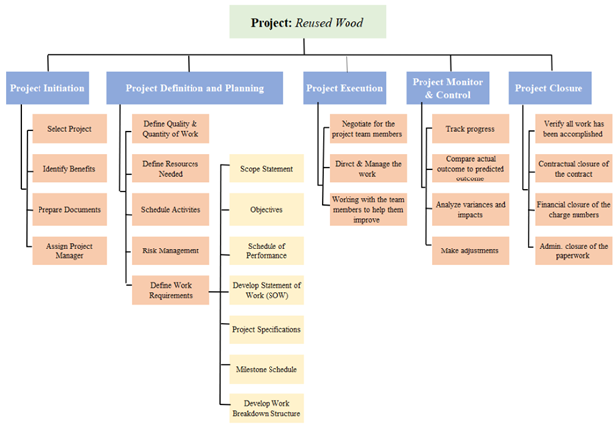
The work breakdown structure is divided into the five stages of project management life cycle: Initiation, Planning, Execution, Monitor & Control, and Closure. It is the general breakdown of project management activities. The diagram is categorized by the stage of the project. The tasks listed under each stage are requirements of the project management process and will need to be completed.

Work Breakdown Structure :
Work Breakdown Structure Diagram

Evaluation of the various risks
We have identified several potential risks. One risk is not acquiring enough wood to be profitable. Another is completely running out of usable wood. It is possible as well that there is not realistically a substantial customer base of individuals interested in old wood. Old wood can also have a lot of problems with itself. Old wood is prone to insects, mold, warping, splintering, etc. Any of these factors could render the wood unusable or require too much work to be a profitable investment. There is also potential risks when it comes to safety standards. We will be requiring staff to work with potentially dangerous machinery. Though training each worker how to properly operate the equipment is a part of the project, accidents do happen. We may face lawsuits or come under fire as a liable party in the event that someone is harmed on the job. There is also potential for natural disasters causing damage. Wood is a highly flammable substance so it will be important to prevent fire hazards. We have also been notified the workspace we are looking into as a potential space for the project headquarters has an issue with flooding during the springtime. Water damage could render our wood and machinery useless and cost us big.

Project Execution

Negotiating for the project team members
Our group worked together to organize logistics to complete our project. There were many areas that required a lot of research to get ironed out. Our group worked together to negotiate how the work would be split up between team members. Throughout the semester, we have each taken different research topics where we worked to gather valuable information on important topics. The members of our team regularly attend meetings where comments and concerns where shared. This helped all members be informed about updates and other crucial information regarding the execution of our project. Our group negotiated the work for our project by discussing who would be interested in doing what areas of the project. We tried to make sure that each member was doing work they were interested in. Stephanie was taken an interest in the benefits of our project. Mikenzie was taken an interest in the process of reusing wood and researching the market for this topic. Trevor has spent time researching the equipment needed to make this project run well. On the other hand, each member has contributed to other parts of the project such as planning and information management.

Directing and managing the work
There has been a lot of directing and managing of work during the semester. We have collected a lot of information about the reusable wood market, process, and the equipment needed for this project. Our group has done a respectable job working to direct and manage the large amount of work we have done during this process. We have done this by working together and communicating regularly. Our group organizes meetings at least once, and most weeks two to discuss our work and how we will direct and manage it. These meetings are in addition to the discussions we have during class time. These meetings have allowed us to stay organized and ahead of schedule on working out any problems that have arisen. In addition, we have been able to direct and manage our work by meeting with Pam Howland several times. Pam has been a great resource for us. She has sent us valuable information, shared her knowledge, and pointed us in the right direction about where to get other information she might not have immediate access to.

Working with the team members to help them improve
Our team was worked well together and as a result pushed each other to improve. Each team member has brought different strengths and weaknesses to our team this semester. Members of our group have been great with information management, time management, and making sure all the group’s output work is of acceptable quality. I think our group has done a good job keeping each other accountable and pushing each other to improve an area of weakness. Our group has not had any discussion to date about team members not carrying their weight.

Project monitoring and control

Tracking Progress
Project Monitoring and Control is leaded by the Project Manager, and suggestions of “shared responsibility between the project and line managers” (Kerzner 12). The progress of the project will continually be tracked. Objective completion is the target of monitoring and control. The ideal way to monitor and control a project is through a management and control system (MCCS), but the scope of the current project has a small size. Based on the small size related to small number of employees and output, an expensive MCCS would not be cost effective, but the main principles of such a system can still be applied.
A suggestion to manage control of the project through basic implementation of some of the standards of MCCS, but on a scale relative to the size of the project. A subsystem of the MCCS is cost control. A basic cost control system that is based upon good cost management principles should be developed. For an effective cost control system, data should be recorded, but the most important step is “also analyzing the data in order to take corrective action before it is too late” (Kerzner 566). The schedule of the project activities will be tracked as well as measuring “resources consumed, measure status and accomplishments,” and “compare measurements to projections and standards” (Kerzner 567).
Budget: The project budget created in the Planning stage will be used to monitor and control the project. Related to the Project Planning stage, the cost data related to quality and quantity of work will be tracked and measured. The four categories are the costs of labor, material, overhead, and other direct charges. The tracking of labor can be accomplished through measures such as a Weekly Labor Report. The material costs can be recorded using earned value measurement, the actual costs for work performed include both direct and indirect costs (Kerzner 598).
Schedule and Milestone Tracking: Related to measuring status and accomplishments, major milestones and victories will be recorded with additional information including the date and time they occur. In addition, any upcoming milestones needed to accomplish or other deliverables due will be tracked as well including the progress of these items. There are many options available to track progress. Some of the options include charts such as Gantt Charts, and the additional data of progress will be added. The chart will need to be frequently updated; one recommendation is on a weekly basis. The specific individuals assigned to each task will also be recorded. The milestones are identified and then the progress towards the milestones will be tracked. All tasks and activities will be identifies as not started, % progress, or completed. Some of the deliverables used to assist this process include work breakdown structure and charts related to the scheduling of activities (Kerzner 568).
Information- Input Material: Related to the small size of the project, simple quality control tools can be implemented to aid in monitoring and control. Simple data tables and check sheets can be designed and used. A check sheet can be used during material receipt and inspection. Various information about the input material can be tracked such as who/where it comes from, date, quantity, direct material cost(?), and other information deemed necessary. The specific details tracked will be determined by the project team using domain knowledge and their experience.
Information – Process: The end-product is wooden floorboards; simple variable control charts may be used to measure control processes of equipment. It would be too costly to acquire very detailed information about every single floorboard but sampling a few boards at random is recommended (process of acceptance sampling). Specific objectives and measures will be identified and determined before sampling, therefore if a problem arises it can be detected if it is outside of acceptable range. During a sampling check various attributes will be tracked to determine overall quality and to measure quality of process and operation. Some attributes that are estimated to be of importance are the size of the boards will be measured (industry standard size), visual inspection for any defects of material, straightness or evidence of warping evaluated, and any other metrics deemed necessary. Some natural variances will occur and that is expected, but these measures will help identify possible problems in a timely manner that will ultimately minimize overall costs.

Comparing actual outcome to predicted outcome
The activities of the project will need to be continually monitored “for compliance with company purpose and philosophy and general corporate policies” (Kerzner 160). Periodically during the project, the project sponsor and project manager are recommended to meet. During the meetings, scope baseline changes will be discussed and then authorized or rejected. The project will only continue with authorized scope changes to reduce the chance of scope creep, by focusing on this the chance of significant cost increases can be minimized (Kerzner 362). The deliverables created during the Project Planning stage and other documentation will be used to aid in the comparison of similarities and differences between the actual outcome and predicted outcome.
One of the important objectives of the project is job creation and benefit to the community, the project will be monitored to verify that the project is continually striving to meet this. This will help ensure that the project does not stray from central objectives and the actual result will be similar to the predicted outcome. Part of the Monitor and Control project life stage includes special emphasis on quality management as the integration of quality management into the overall project management is essential for optimal outcome. The principles of quality management will govern the reused wood process to ensure a quality trading good.
The following six quality management concepts will be applied to the project: Quality policy, quality objectives, quality assurance, quality control, quality audit, and quality program plan (Kerzner 771). These principles will be applied to the processing of the wood, organizational values and culture, and to the project itself.

Analyzing variances and impacts
There will be several variances as our project is monitored and controlled. The first variance will be how we get the wood to then be reused. Our group has produced several ways we think getting this wood would be easiest. Pam mentioned she thinks it would be a clever idea to ask the City of Springfield to get a list of demolition permits issued recently. This would allow us to go to those sites and see if we could retrieve any of this wood. In addition, we could work with local house flippers to get wood from their projects. Another idea our group had for a source of wood could be contacting local small town waste sites to see if they would be interested in donating some of their wood to our business. This would allow flippers and waste sites to cut down on the cost of disposing of their wood.
The next variance we must deal with is the condition of the wood as it arrives. The age of the wood could vary greatly. This could affect the process of reusing it. Older wood could force us to spend more time transforming into a final product. In addition, some wood might have other materials such as siding, or nails attached to it. This would force us to spend more time and labor on removing other materials from the wood upon arrival.
The final product will also have variances. Our reused wood hub would produce several products that vary from one another. Even the same products might have variances when accounting for size, shape, etc. As a result, the process of reusing a piece of wood will vary too. This might mean using different machines and different methods depending on the desired final outcome.

Making adjustments
Many adjustments have been made and many more will still need to happen before the project can really take off. As mentioned before, the project began as Recycled Wood and became Reused Wood. This is just one example of how the project has changed since its selection. Another adjustment we have already made in regards to the project is altering the customer base. We were initially focused primarily on contractors, but we have expanded slightly to include interior designers who are interested in maintaining the aesthetic quality of the old wood we will be reusing. We are still in the Project Planning phase and the project will inevitably change as more is discovered about the project and as the project continues.

Project Closure

Verifying that all of the work has been accomplished
The closure of our project relates to verifying that all the work has been accomplished or completed. We feel as a group that we have made as much progress as possible on this project during the semester. We have done ample research on resources, processes, and logistics needed to make this project a reality. Most importantly, we have gotten as far as possible with finding funding and a location. Our group believes that we have made enough progress that another group could pick up where we left off and have more than enough information to make their project a success. Our team has organized our projects execution into phases found in the scheduling of activities. The training program accomplishes the safety and training part of our project. During this stage, new employees will be trained in how safely work all the equipment in the workshop and to tune their wood working skills. The project initiation and planning phase took up much of our time this semester. We were able to organize a lot of the organization such as location, number of employees, operations, and financials. In addition, our group worked hard to determine which resources would be needed for the project. We were able to accomplish a list of resources that includes wood working machines such as sanders and saws, trucks, dumpsters, employees, and a building. The execution and monitoring of the project have not been accomplished as the project is not yet completed.

Contractual closure of the contract
Our group did not secure any contracts during the semester. Our goal in the future would be to secure contracts with local dump sites. The dump sites we would aim to sign contracts with are local town dumps where residents drop off their trash and waste. This could be done in smaller towns in Western Massachusetts. These contracts would allow us to get some of the wood waste from these dump sites so we can use it to be reused. Our company will come up with a file of a draft contract clause. This idea comes from Page 830 of the Kerzner text. This could allow us to more easily secure contracts with various dump sites. There are several documents we fill need to fill out to register our business with the City of Springfield. In addition, we will need to submit a Certificate of Occupancy application. Other licenses that will be needed include a federal tax ID and a Sales Tax Permit from the Massachusetts Department of Revenue.

Financial closure of the charge numbers or members
Our group concluded based on our conversations with Pam that our project would need about $200,000 for the first year of operations. There are several ways our group thought about to secure this much money. The first idea was government assistance for small businesses. Pam thought it could be possible to apply for these assistance programs and receive some money to assist with these costs. Our group would also plan to apply for several grants that could assist with funding. The Kerzner text has a section that discusses pricing and financial estimates. Our group used this portion on the textbook also to produce our $200,000 estimate for the first year of operation. This section of the textbook starts on page 513. The financial closure is especially important to the success of our project, so we spent ample time formatting our estimates.

Administrative closure of the paperwork
Our group has many digital documents that will be helpful for future teams pursuing the continuation of this project. One such document is the Running Notes which have been finalized and updated to include our final meetings. We have also shared our answers from interviews we have conducted over the course of the semester which can be used as helpful guiding tools for future teams and clearly express the vision for the future of this project.
There is usually a contract administrator assigned to the project whose job is handling administrative change, change order, contract modification, undefined contractual action, supplemental agreement, and constructive change. This means that they are in charge of handling any changes that may occur involving contracts. We do not have any such contracts of paperwork at this time, but as the project progresses, there will be paperwork to be closed out and finalized in this sense.

Appendix

Appendix A
Information about the Training Program was gathered from the following eight page document:
“2020 APPLICATION FOR COMMUNITY PRESERVATION ACT (CPA) FUNDING
GREATER NEW LIFE CHRISTIAN CENTER and YOUTH SOCIAL EDUCATIONAL TRAINING, INC.
REUSEWOOD to REBUILDWEALTH”
